**VISVESVARAYA TECHNOLOGICAL UNIVERSITY**

**“JNANA SANGAMA” Belagavi, Karnataka- 590 018**



2025-2026

A Report On

**“Social Connect and Responsibility”**

**Subject code: BSCK307 Submitted in partial fulfillment of the requirement to award the degree of “Bachelor of Engineering in ComputerScience and Engineering”**

**Submitted By**

**Bhumika B.C**

**[1AH24CS023]**

**Under the Guidance of**

**Ms Divya S**

**Assistant Professor,**

**Dept of CSE**



**Department of Computer Science Engineering**

**ACS COLLEGE OF ENGINEERING,**

**Kambipura Mysore Road, Bangalore- 560 074**

**Computer Science Engineering, ACS College Of Engineering Page | 1**

**ACS COLLEGE OF ENGINEERING**

**Kambipura Mysore Road, Bangalore- 560 074**

**DEPARTMENT OF COMPUTER SCIENCE ENGINEERING**



***CERTIFICATE***

This is to certify that Ms. Bhumika B.C bearing university register

number **1AH24CS023** carried out **“Social Connect and Responsibility” (BSCK307)** as per VTU Curriculum, in partial fulfillment of award of the degree of **Bachelor of Engineering in Computer Science Engineering, from**

**Visvesvaraya Technological University, Belgaum** during the year **2025-2026**.The subject report has been approved as it satisfies the academic requirement in respect of Internship presentation prescribed for the degree.

Signature of Faculty Incharge Signature of HOD

**Ms. Divya S Dr. Nandagopal S M**

**Asst Professor HOD**

Dept. of Computer Science Engineering Dept. of Computer Science Engineering

ACSCE, Bangalore ACSCE, Bangalore

**Computer Science Engineering, ACS College Of Engineering Page | 2**

**ACS COLLEGE OF ENGINEERING**

**Kambipura Mysore Road, Bangalore- 560 074**

**DEPARTMENT OF COMPUTER SCIENCE ENGINEERING**



***DECLARATION***

I, Bhumika B.C the student of third semester of Computer Science Engineering, ACS college of Engineering, Banglore-560074, declare that the report entitled “Social Connect and Responsibility” has been successfully completed under guidance of Ms. Divya S, Asst Professor and Department of Computer Science Engineering, ACS College Of Engineering, Bangalore. This dissertation work is submitted to Visvesvaraya Technological University in partial fulfillment of the requirements for the award of degree of Bachelor of Computer Science Engineering during the academic year 2025- 2026.

Place: Bengaluru Bhumika B.C

Date: 29th December 2025 [1AH24CS023]

**Computer Science Engineering, ACS College Of Engineering Page | 3**

**ACKNOWLEDGEMENT**

It is my proud privilege and duty to acknowledge the kind of help and guidance received from several people in preparation of this report. It would not have been possible to prepare this report in this form without their valuable help, cooperation and guidance.

First and foremost, I wish to record my sincere gratitude to the

**Management of ACS College of Engineering** and to our beloved Principal, **Dr B S Shailaja,** **ACS College of Engineering**, Bangalore for his constant

support and encouragement in preparation of this report and for making available library and laboratory facilities needed to prepare this report.

My sincere thanks to **Ms. Diya S, Asst Professor**, Department of Computer Science Engineering, ACSCE, for her valuable guidance and allowing us to conduct investigations for this project. The numerous discussions with her were extremely helpful. I hold her in esteem for guidance, encouragement and inspiration received from her.

My sincere thanks to all professors for supporting the work related to this project. Their contributions and technical support in preparing this report are greatly acknowledged.

Finally, I thank my family, friends and all those who always encouraged me and helped me in all acknowledged the possible ways for my studies. I wish to thank my parents for financing my studies in this college as well as for constantly encouraging me to pursue engineering. My parent’s personal sacrifice in providing this opportunity to pursue engineering is greatly acknowledged.

Bhumika B.C

[1AH24CS023]

**Computer Science Engineering, ACS College Of Engineering Page | 4**

**CONTENTS**

|  |  |  |
| --- | --- | --- |
| SL.No | Contents | Page No. |
| 1 | Syllabus | 6 |
| 2 | Introduction | 7 |
| 3 | Module-1:- Plantation and Adoption of a Tree | 8-13 |
| 4 | Module-2:- Heritage Walk and Crafts Corner | 14-19 |
| 5 | Module-3:- Organic Farming and Waste Management | 20-31 |
| 6 | Module-4:- Water Conservation | 32-40 |
| 7 | Module-5:- Food Walk | 41-46 |
| 8 | Summary | 47 |
| 9 | Conclusion | 48 |

**Computer Science Engineering, ACS College Of Engineering Page | 5**

**SYLLABUS**

|  |
| --- |
| **Objectives:** The Course will  • Enable the student to do a deep drive into societal challenges being addressed by  NGO(s), social enterprises & The government and build solutions to alleviate these complex social problems through immersion, design & technology.  • Provide a formal platform for students to communicate and connect with their surroundings.  Enable to create of a responsible connection with society |
| **Learning Outcomes:** The students are expected to have the ability to :  1. Understand social responsibility  2. Practice sustainability and creativity  3. Showcase planning and organizational skills |
| **Contents:**  The course is mainly activity-based that will offer a set of activities for the student that enables them to connect with fellow human beings, nature, society, and the world at large.  The course will engage students interactive sessions, open mic, reading groups, storytelling sessions, and semester-long activities conducted by faculty mentors. In the following a set of activities planned for the course have been listed. |
| **Module-1:-** |
| **Plantation and adoption of a tree:** Plantation of a tree that will be adopted for four years by a group of B.Tech. Students. They will also make an excerpt either as a documentary or  a photoblog describing the plant’s origin, its usage in daily life, and its appearance in folklore and literature. |
| **Module-2:-** |
| **Heritage walk and crafts corner:** Heritage tour, knowing the history and culture of the  city, connecting to people around through their history, knowing the city and its craftsman,  photoblog and documentary on evolution and practice of various craft forms. |
| **Module-3:-** |
| **Organic farming and waste management:** usefulness of organic farming, wet waste management in neighboring villages, and implementation in the campus. |
| **Module-4:-** |
| **Water Conservation:** knowing the present practices in the surrounding villages and implementation in the campus, documentary or photo blog presenting the current practices. |
| **Module-5:** |
| **Food Walk** City’s culinary practices, food lore, and indigenous materials of the region used in cooking. |

**Computer Science Engineering, ACS College Of Engineering Page | 6**

**INTRODUCTION**

Social connection and social responsibility are two interconnected concepts that play a crucial role in fostering a healthy and sustainable society.

Social connection is an essential human need that enables us to establish meaningful relationships with others. Social responsibility means individuals and organizations have a duty to act ethically and contribute to the well-being of society and the environment, beyond just legal requirements or profit, by making decisions that benefit the community, support sustainability. It involves building a sense of belonging, support, and community with those around us, including our friends, family, neighbors, and colleagues. Social connection plays a vital role in promoting our physical and mental well-being, reducing stress and anxiety, and improving our overall quality of life.

Whereas Social responsibility means individuals and organizations have a duty to act ethically and contribute to the well-being of society and the environment, beyond just legal requirements or profit, by making decisions that benefit the community, support sustainability. It involves making sustainable and ethical decisions that prioritize the well-being of people, the planet, and future generations. Social responsibility is critical in creating a sustainable future, where everyone has access to the necessary resources, and the environment is protected.

One example of social responsibility is ensuring that all people have access to quality healthcare, regardless of their financial situation or geographical location. This can be achieved by eliminating barriers such as distance and cost. Another example is reducing waste and conserving natural resources, which require a collaborative effort from individuals, businesses, and government. The course on social connection and social responsibility will focus on providing students with practical activities to engage with fellow humans, nature, society, and the world at large. Through interactive sessions and group activities, students will learn how to build meaningful relationships, contribute to their communities, and promote sustainable practices.

By the end of the course, students will have a better understanding of the importance of social connection and social responsibility and be equipped with the necessary skills to make a positive impact on society and the environment.

**Computer Science Engineering, ACS College Of Engineering Page | 7**

**MODULE 1 – PLANTATION AND ADOPTION OF A TREE**

**Introduction:**

Plantation of a tree that will be adopted for five years by me (Bhumika B.C). On a date of **13th December 2025.** I planted a periwinkle flower plant at my homein Bangalore and I am taking care of it for five years.

**Overview:**

Periwinkle refers to plants in the Vinca and Catharanthus genera, known for beautiful, often blue or pink flowers, hardiness, and use as ground cover, but it also has significant medicinal uses, especially Catharanthus roseus (Madagascar Periwinkle), providing compounds like vincristine for cancer treatment and vinpocetine for circulation issues, though it's toxic and requires caution.

* **Height**: 30 to 90 centimeters (1 to 3 feet)
* **Lifespan**: lives 5-10 years
* **Leaves**: typically oval to oblong, glossy green, and arranged in opposite pairs along the stem and range from 1 to 9 cm (0.4 to 3.5 inches) in length
* **Stems**: herbaceous (non-woody) to semi-woody at the base.
* **Fruit**: produces a dry, inconspicuous, paired fruit called follicles, which are green, pod-like, and split open to release tiny seeds.

**Computer Science Engineering, ACS College Of Engineering Page | 8**



Periwinkle Plant

**Site Selection for Compost Piles:**

When selecting a site for a compost pile, there are several factors to consider:

* **Containment:** The most important factor is to ensure the periwinkle cannot escape the compost pile. The plant's stems readily root where they touch the ground.
  + **Avoid typical garden compost heaps:** Many gardeners and experts advise *against* putting periwinkle stems, roots, or seeds into a regular compost bin, as it is highly likely to continue growing and spread the plant to other parts of your garden when you use the finished compost.
  + **Use a secure container:** Consider using a sealed container (like a plastic bin with a lid) rather than an open pile. This prevents stems from reaching the soil and rooting.
* **Sunlight:** The location should preferably be in **full sun** if your goal is to help the material break down and dry out more quickly. Periwinkle can tolerate partial shade, but intense sun can help kill off stubborn plant parts.
* **Drainage:** The site must have **well-drained soil** and be located on elevated ground with a gentle slope to prevent waterlogging. Good drainage helps maintain proper composting conditions and reduces the risk of root rot or fungal diseases.
* **Isolation:** The site should be located away from natural areas, garden beds, or water bodies where the periwinkle could potentially spread and outcompete native plants. A location

**Computer Science Engineering, ACS College Of Engineering Page | 9**

bordered by concrete, sidewalks, or a lawn is a good option.

* **Accessibility:** Choose a spot that is easily accessible so you can manage the pile, monitor it for new growth, and add new material as needed.

**Picture:**

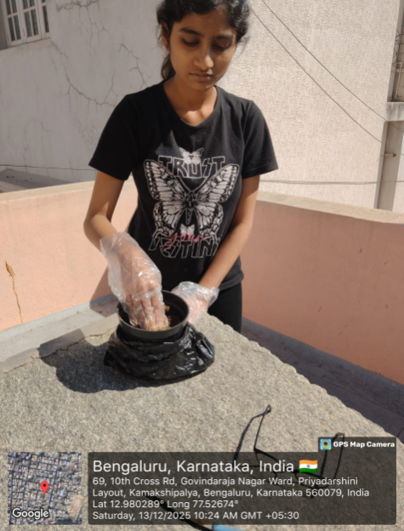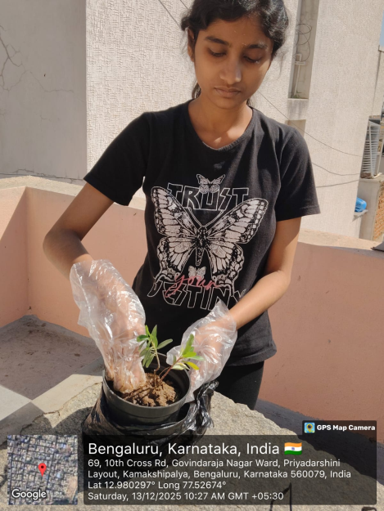 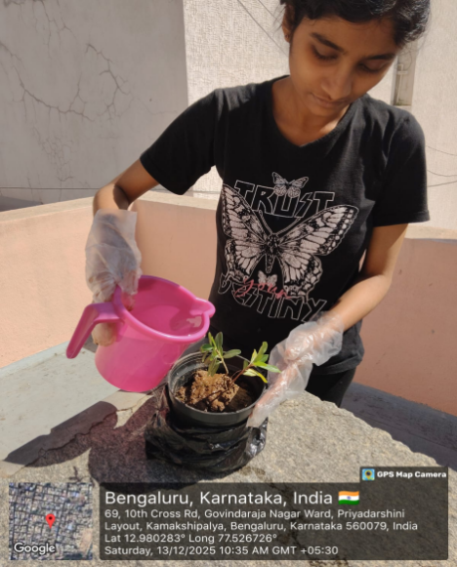

Plantation of Periwinkle plant

**Computer Science Engineering, ACS College Of Engineering Page | 10**

**Benefits and impacts:**

Plantation is the act of planting trees or crops in a designated area for economic or environmental purposes. The concept of plantation has been around for centuries, with historical examples such as the large-scale sugar plantations in the Caribbean and the cotton plantations in the southern United States. However, modern-day plantation practices often focus on sustainable forestry and agriculture practices to promote long-term environmental health and economic benefits.

Plantations can have a wide range of economic and environmental benefits, depending on the type of trees or crops being grown and the management practices used. For example, timber plantations can provide a sustainable source of wood products for construction and manufacturing industries, while also sequestering carbon and promoting biodiversity.

Similarly, agricultural plantations such as those growing coffee or cocoa can provide a source of income for farmers and communities, while also preserving natural habitats and promoting soil health.

However, there are also potential negative impacts of plantation practices. Large-scale monoculture plantations can lead to soil degradation and erosion, loss of biodiversity, and negative impacts on local communities and indigenous peoples. Additionally, unsustainable harvesting practices or the use of harmful chemicals can lead to environmental degradation and negative health impacts.

To promote sustainable plantation practices, it is important to consider a range of factors such as soil health, biodiversity, local communities and indigenous peoples, and long-term economic benefits. This may involve using a variety of tree or crop species to promote biodiversity, implementing sustainable harvesting practices, and engaging with local communities and stakeholders to ensure that plantation practices are equitable and beneficial for all involved.

**Computer Science Engineering, ACS College Of Engineering Page | 11**

**Importance Of Plantation:**

1. **Produce Oxygen & Clean Air:**

Trees absorb carbon dioxide and release vital oxygen through photosynthesis, while also filtering pollutants and particulates from the air.

1. **Combat Climate Change:**

By sequestering large amounts of CO2, trees help mitigate global warming.

1. **Prevent Soil Erosion & Flooding:**

Tree roots hold soil, preventing erosion, and their canopies break rainfall, reducing stormwater runoff and water pollution.

1. **Support Wildlife:**

Trees offer essential food, shelter, and nesting sites for countless bird, insect, and mammal species, supporting biodiversity.

1. **Regulate Water Cycle:**

They help filter water, recharge groundwater, and influence rainfall patterns.

1. **Reduce Energy Costs:**

Strategic tree placement provides shade, lowering summer cooling needs for buildings and reducing energy bills.

1. **Boost Mental & Physical Health:**

Access to trees reduces stress, improves focus, and can lower crime rates in urban areas, benefiting mental well-being.

1. **Provide Food & Medicine:**

Trees yield fruits, nuts, and ingredients for many medicines (like aspirin from willow bark).

1. **Enhance Beauty & Property Value:**

Trees beautify landscapes, making neighborhoods more attractive and increasing property values.

1. **Create Jobs & Resources:**

They provide wood, paper, and create jobs in forestry and landscaping, contributing to economies.

**Computer Science Engineering, ACS College Of Engineering Page | 12**

**Conclusion :**

The plantation event was successful done by me. I thank my parents to provide the place where I was able to plant and take care for next five years.

However, plantation practices can provide a range of economic and environmental benefits, but must be managed carefully to avoid negative impacts on the environment and local communities. By promoting sustainable practices and engaging with stakeholders, plantations can play an important role in promoting long-term environmental health and economic benefits.

**Computer Science Engineering, ACS College Of Engineering Page | 13**

**MODULE 2- HERITAGE WALK AND CRAFT CORNER**

**Introduction:**

Heritage walk and craft corner was planned on **12th December 2025 and 13th December 2025**. We visited the **Bangalore Fort** which is located in **Bagalore District** about the distance of 17.6km from our college (**ACS College of Engineering**) and for craft corner visited **Kushala Kala** which is located in **Channapatna District** about the distance of 52km from our college.

**Overview:**

Bangalore Fort, originally a mud fort from 1537 by Kempe Gowda I, was transformed into a stone fort by Haider Ali in 1761 and later improved by Tipu Sultan, serving as a significant site for the Mysore Empire's struggle against the British.

* **Founder:** Kempe Gowda I (1537) built the initial mud fort.
* **Transformation:** Haider Ali rebuilt it with stone in 1761, and Tipu Sultan strengthened it further.
* **British Capture:** The British East India Company, led by Lord Cornwallis, captured it in 1791 during the Third Anglo-Mysore War.
* **Decline:** After capture, much of the fort was dismantled by the British, with parts repurposed for schools and roads.

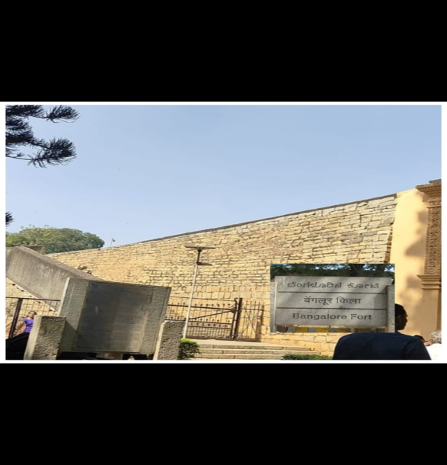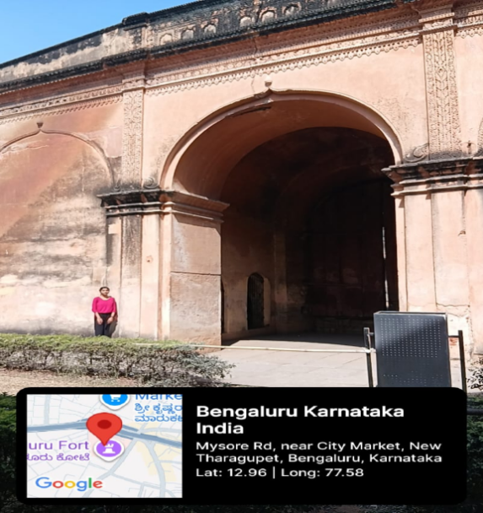

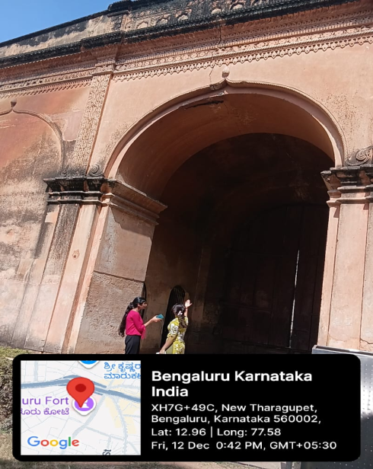

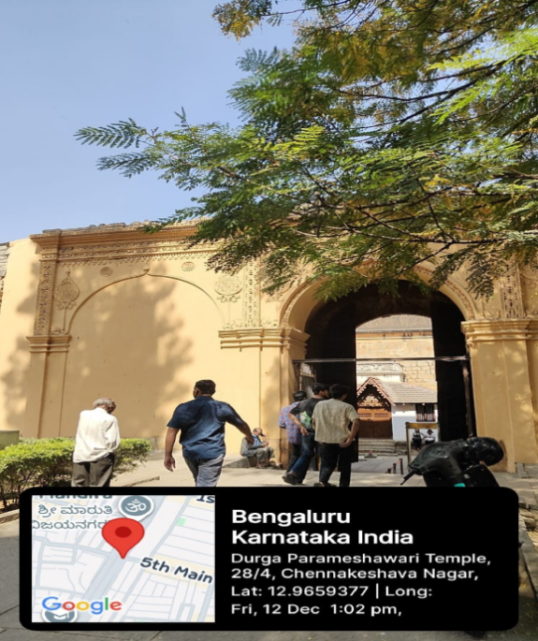

**Computer Science Engineering, ACS College Of Engineering Page | 15**

**History Of Banglore Fort**

**Bangalore Fort** began in 1537 as a mud fort. The builder was Kempe Gowda I, a vassal of the Vijaynagar Empire and the founder of Bangalore. King Hyder Ali in 1761 replaced the mud fort with a stone fort and it was further improved by his son King Tipu Sultan in the late 18th century. Though damaged during an Anglo-Mysore war in 1791, it still remains a good example of 18th-century military fortification. The army of the British East India Company, led by Lord Cornwallis on 21 March 1791 captured the fort in the siege of Bangalore during the Third Mysore War (1790–1792). At the time the fort was a stronghold for King Tipu Sultan. Today, the fort's Delhi gate, on Krishnarajendra Road, and two bastions are the primary remains of the fort. A marble plaque commemorates the spot where the British breached the fort's wall, leading to its capture. The old fort area also includes King Tipu Sultan's Summer Palace, and his armoury. The fort provided the setting for the treasure hunt in the book Riddle of the Seventh Stone.

**Fort structure**

Bangalore, like Madras, had a fort, with a *pettah*, or fortified town, outside it. This lay-out was a feature of almost all the cities or settlements in India, the fort providing a place of refuge for most of the inhabitants if the *pettah* was in danger of capture. The fort at Bangalore had a perimeter of about one mile; it was of solid masonry, surrounded by a wide ditch which was commanded from 26 towers placed at intervals along the ramparts. To its north lay the *pettah*, several miles in circumference and protected by an indifferent rampart, a deep belt of thorn and cactus, and a small ditch. Altogether Bangalore was not a place which invited attack.

**Computer Science Engineering, ACS College Of Engineering Page | 16**

**Importance Of Histortical Walk:**

* **Cultural Understanding:** Fosters cultural sensitivity, respect, and understanding for diverse traditions and communities.
* **Raises Awareness:** Highlights the importance of historical sites, encouraging public support for their protection.
* **Supports Conservation:** Drives interest and funding for conservation projects and the preservation of monuments.
* **Documenting History:** Encourages the collection and sharing of authentic information about heritage sites.
* **Sustainable Tourism:** Promotes sustainable tourism by offering enriching experiences beyond typical attractions.
* **Economic Boost:** Supports local guides, artisans, and businesses, benefiting the community.
* **Engages Youth:** Serves as an effective, interactive tool for students to learn about their cultural legacy.

**Computer Science Engineering, ACS College Of Engineering Page | 17**

**KUSHALA KALA {CRAFT CORNER}:**

Is India’s first crafts park and is located at Channapatna in Karnataka, South India, Channapatna is a craft cluster of over 3000 traditional artisians engaged in the production of Lacquerware. The park was established to help, preserve, nurture and grow skills, by providing artisians with employment opportunities.

This has been done through the provision of Infrastructure and manufacturing facilities to exporters engaged in the production of woodcraft, Lacquerware and natural fibre.

This project is funded under ASIDE scheme. The objective of the scheme is to involves the states in the export effort by providing assistance to the state government for creating appropriate infrastructure for the development and growth of exports



Kushala Kala{Craft Corner}

I had a wonderful experience while manufacturing few parts of toys. Gained the knowledge of methods which they are practicing, the natural color which they use to paint the parts of the toys.

**Computer Science Engineering, ACS College Of Engineering Page | 17**

**Importance Of Crafts:**

* **Enhances Mental Well-being**: Engaging in crafts is a therapeutic activity that can reduce stress and anxiety, improve mood, and provide a healthy emotional outlet for self-expression.
* **Develops Skills**: Crafting involves hands-on activities like cutting, drawing, and assembling, which helps improve fine motor skills, hand-eye coordination, and problem-solving abilities.
* **Promotes Organization and Responsibility**: Designing and maintaining a craft corner, including organizing supplies in labeled bins and shelves, helps teach organizational skills and a sense of ownership over one's space and materials.
* **Encourages Connection and Social Skills**: Craft activities can be a shared experience, fostering teamwork, communication, and stronger bonds among family members or community groups.
* **Boosts Confidence and Self-Esteem**: Successfully completing a project in their own space gives individuals a sense of accomplishment and pride, which builds self-confidence that can extends to other areas of life.

**Computer Science Engineering, ACS College Of Engineering Page | 18**

**Conclusion :**

A heritage walk allows individuals to immerse themselves in the rich tapestry of history, architecture, and traditions that define a particular locality or region. It provides a unique opportunity to explore landmarks, monuments, and buildings that bear witness to the past, offering insights into the lives of those who came before us. By strolling through these historic streets and sites, visitors can gain a deeper understanding of the cultural heritage and legacy that shapes the identity of a community.

Meanwhile, a crafts corner provides a window into the creativity and craftsmanship of local artisans and craftsmen. It showcases a diverse array of traditional and contemporary arts and crafts, ranging from handmade textiles and pottery to intricate woodwork and metalwork.

Visitors have the chance to witness skilled artisans at work, creating unique and authentic pieces that reflect the cultural heritage and artistic traditions of the region.

Together, a heritage walk and a crafts corner offer a holistic experience that celebrates the cultural richness and artistic diversity of a place. They provide opportunities for cultural exchange, learning, and appreciation, fostering a deeper connection to the past and present.

Whether exploring ancient monuments or admiring handmade crafts, visitors are sure to be inspired by the beauty and creativity that abound in these cultural gems.

**Computer Science Engineering, ACS College Of Engineering Page | 19**

**MODULE 3 – ORGANIC FARMING AND WASTE**

**MANAGEMENT**

**Introduction:**

Organic farming and waste management are essential components of sustainable development. In the context of a campus, these practices can have a significant impact on the environment and the health and well-being of students, faculty, and staff. This report aims to provide an overview of organic farming and waste management practices in a campus setting.

**Organic farming:**

Organic farmers focus on building and maintaining healthy soil through practices such as crop rotation, cover cropping, composting, and the use of natural soil amendments like manure and organic matter. Healthy soil is crucial for nutrient retention, water retention, and promoting beneficial microorganisms that support plant growth.

Organic farming encourages crop diversity, both within individual fields and across the farm. Crop rotation helps prevent soil erosion, reduces pest and disease pressure, and improves soil fertility by varying the types of plants grown in a particular area over time.

Instead of relying on synthetic pesticides and herbicides, organic farmers use techniques such as integrated pest management (IPM), biological control, beneficial insect habitat enhancement, and physical barriers to manage pests and diseases. This approach minimizes harm to beneficial insects, pollinators, and other wildlife.

Organic farming prohibits the use of synthetic chemicals, including synthetic fertilizers, pesticides, herbicides, and genetically modified organisms (GMOs). Instead, farmers use natural and organic Inputs such as compost, manure, crop residues, botanical extracts to nourish plants and manage pests.

Organic farming practices promote biodiversity, reduce soil erosion, conserve water, and minimize pollution of air, soil, and waterways. By avoiding synthetic inputs and promoting natural ecosystem processes, organic farming contributes to environmental conservation and mitigates climate change.

**Computer Science Engineering, ACS College Of Engineering Page | 20**

**Types Of Organic Farming**

Organic farming broadly falls into two main types, **Pure Organic Farming**, which strictly avoids all synthetic inputs, and **Integrated Organic Farming**, which combines natural methods with efficient resource cycles, alongside specialized systems like **Biodynamic Farming**, Permaculture, and Natural Farming(like ZBNF), all focusing on ecological health, soil fertility, and sustainability.

**Main Types**

* **Pure Organic Farming:** A strict approach using only natural fertilizers (compost, manure) and bio-pesticides, completely banning synthetic chemicals and GMOs, ideal for 100% natural produce.
* **Integrated Organic Farming:** Combines crop cultivation with livestock, aquaculture, and waste recycling to create a self-sustaining, zero-waste system where one output feeds another, boosting efficiency.

**Specialized Systems & Methods**

* **Zero Budget Natural Farming (ZBNF):** Low-cost farming using cow dung/urine-based inputs (Jeevamrutha, etc.) to build soil fertility without external chemicals.
* **Biodynamic Farming:** Views the farm as a living organism, integrating cosmic rhythms, specific composts, and herbal preparations for holistic health.
* **Permaculture:** Designs self-sustaining ecosystems with diverse plants, animals, and people in balanced, natural patterns.
* **Polyculture & Crop Rotation:** Growing diverse crops or rotating different crops seasonally to enhance biodiversity, break pest cycles, and renew soil nutrients.
* **Agroforestry & Mixed Cropping:** Integrating trees, crops, and sometimes livestock for balanced ecosystems, soil health, and reduced pest pressure.

**Core Practices Used Across Types**

* Composting & Green Manuring
* Mulching
* Natural Pest & Weed Control
* Water Harvesting & Soil Conservation

**Computer Science Engineering, ACS College Of Engineering Page | 21**

**E-Waste:** Discarded electronics and batteries.

* **Liquid Waste:** Wastewater, industrial effluents, chemicals.

**Process of Organic farming and waste management**

Organic farming is a method of agriculture that involves cultivating crops and raising animals without the use of synthetic fertilizers, pesticides, genetically modified organisms (GMOs), or other harmful chemicals.

Here is a brief overview of the process of organic farming:

i**. Soil management**: Organic farmers focus on maintaining healthy soil by using natural

methods such as crop rotation, cover crops, and composting to enhance the soil's

fertility and structure.

ii**. Pest management**: Organic farmers use a variety of methods to manage pests and

diseases, including crop rotation, natural predators, and physical barriers

iii. **Seed selection**: Organic farmers select seeds that are adapted to the local climate and

soil conditions, and are often heirloom or open-pollinated varieties.

iv. **Crop management**: Organic farmers use a variety of methods to manage their crops,

such as intercropping, companion planting, and natural weed control.

v. **Livestock management**: Organic livestock must be raised in humane conditions,

with access to outdoor grazing areas and organic feed.

**Category and source of Organic Waste**

Organic waste refers to any type of waste that is biodegradable and comes from plant or animal sources. Here are the categories of organic waste:

i. **Food waste** - Uneaten or expired food from households, restaurants, supermarkets,

and food processing plants.

ii. **Agricultural waste** - Crop residue, manure, and other organic materials from farms.

iii**. Green waste** - Grass clippings, leaves, branches, and other yard waste.

iv. **Animal waste** - Manure, bones, and other organic materials from livestock and poultry.

**Computer Science Engineering, ACS College Of Engineering Page | 22**

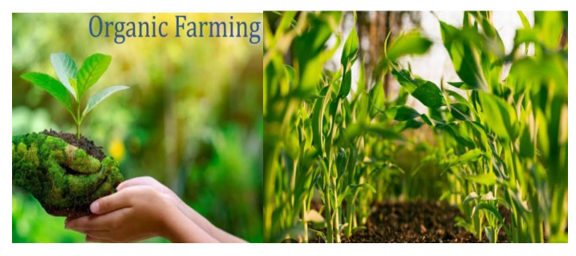

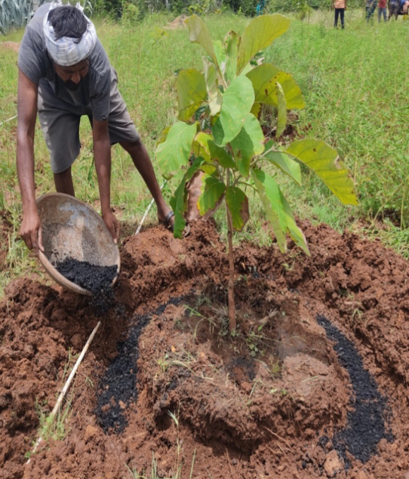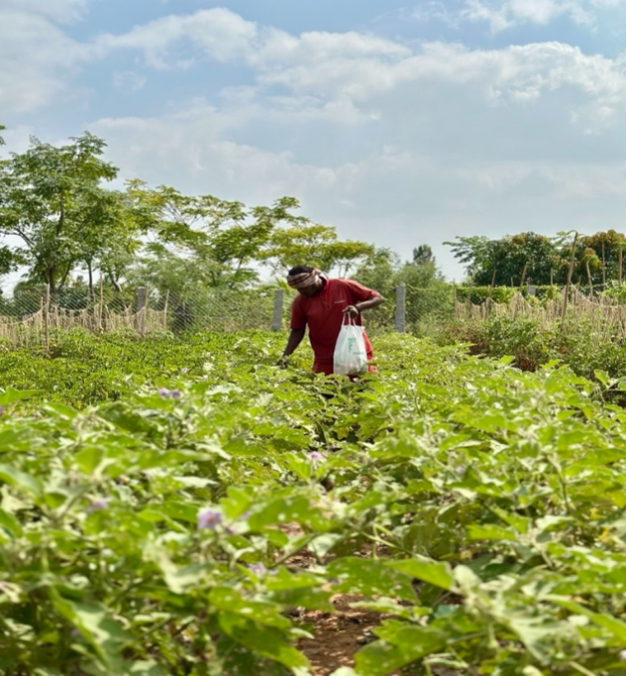

Organic Farming

**Computer Science Engineering, ACS College Of Engineering Page | 23**

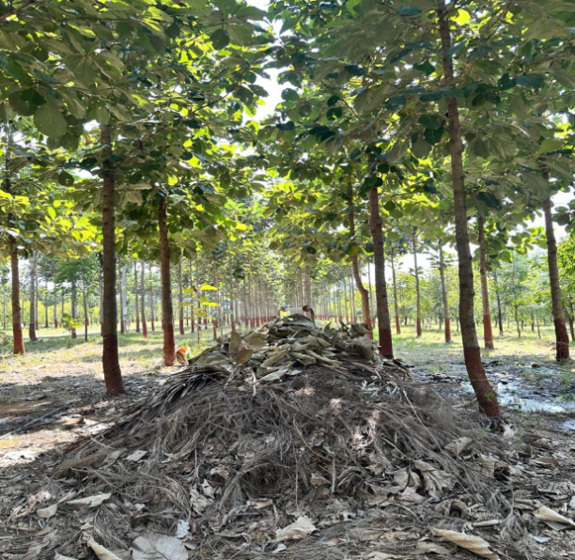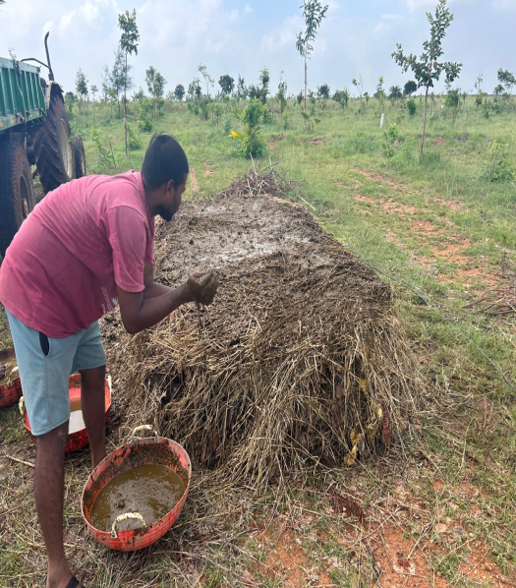

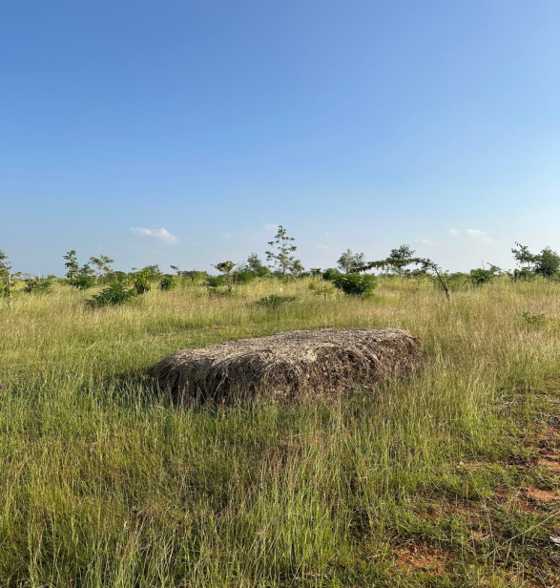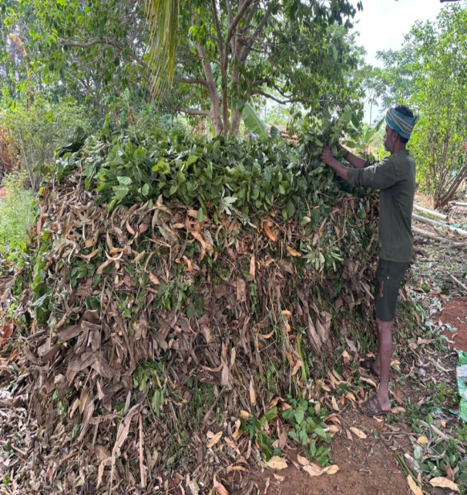

**Computer Science Engineering, ACS College Of Engineering Page | 24**

**Importance Of Oragnic Farming**

* **Soil Health:** Improves soil structure, fertility, water retention, and biological activity using compost and crop rotation, preventing erosion.
* **Biodiversity:** Creates habitats for pollinators, beneficial insects, and wildlife by avoiding harmful pesticides, supporting resilient ecosystems.
* **Reduced Pollution:** Minimizes chemical runoff and leaching into water bodies, protecting water quality and reducing air pollution.
* **Climate Change Mitigation:** Sequesters carbon in the soil, reduces energy use (less synthetic fertilizer/pesticides), and lowers greenhouse gas emissions.
* **Healthier Food:** Produces food free from synthetic pesticides, herbicides, GMOs, hormones, and antibiotics, with potentially higher antioxidants and lower contaminants.
* **Safer Workplaces:** Reduces exposure to toxic chemicals for farmers and farmworkers.
* **Sustainable Livelihoods:** Can offer better incomes for farmers through premium pricing and create more local employment.
* **Resource Efficiency:** Optimizes natural resource use (water, energy) and reduces reliance on expensive external inputs.
* **Innovation:** Drives innovation in biological pest control, nutrient management, and sustainable farming techniques.

**Computer Science Engineering, ACS College Of Engineering Page | 25**

**Conclusion**

Its conclusion points to a vital, growing role in ensuring food security, environmental protection, and healthier diets for future generations.

Organic farming is a holistic, sustainable approach that promotes ecological health and human well-being by avoiding synthetic chemicals, building soil fertility naturally, conserving water, and boosting biodiversity, though it faces challenges like lower yields and higher costs.

**Computer Science Engineering, ACS College Of Engineering Page | 26**

**Waste management:**

Waste management involves collecting, transporting, processing, and disposing of waste in an environmentally responsible manner. It includes strategies such as recycling, composting, wasteto-energy, and landfill management to minimize environmental impact and promote sustainability.

Effective waste management requires collaboration among government agencies, businesses, communities, and individuals to implement waste reduction strategies, promote recycling and composting, and ensure proper disposal of waste materials in accordance with environmental regulations and best practices. By adopting sustainable waste management practices, we can minimize the environmental impact of waste generation and move towards a more circular economy.

Waste management involves various methods like **landfilling, incineration, recycling, and composting**, often following a hierarchy: **reduce, reuse, recycle**, then recover energy (waste-to-energy), and finally dispose (landfill) as a last resort, handling diverse waste types suchasmunicipal(household),hazardous(chemicals,batteries), biomedical(hospital), industrial, and e-waste (electronics) to minimize environmental impact and conserve resources.

**Waste Management Methods**

* **Landfilling:** Burying waste in designated areas, cost-effective but can cause pollution.
* **Incineration:** Burning waste at high temperatures to reduce volume, sometimes generating energy, but can release pollutants.
* **Recycling:** Processing used materials (paper, plastic, glass, metal) into new products.
* **Composting:** Decomposing organic waste (food scraps, yard waste) into nutrient-rich soil.
* **Waste-to-Energy (WTE):** Converting non-recyclable waste into heat, electricity, or fuel.
* **Biological/Mechanical Treatment (MBT):** Combining physical sorting and biological processes for stabilization.

**Waste Management Hierarchy (Prioritized Approach)**

1. **Reduce:** Minimize waste generation at the source (e.g., less packaging).
2. **Reuse:** Extend product life by using items multiple times.
3. **Recycle:** Turn waste into new materials.
4. **Recover:** Extract energy or materials from waste.
5. **Dispose:** Landfilling as the final option for residual waste.

**Computer Science Engineering, ACS College Of Engineering Page | 27**

**Types of Waste Managed**

* **Municipal Solid Waste (MSW):** Household garbage, food waste.
* **Hazardous Waste:** Chemicals, batteries, medical waste.
* **Biomedical Waste:** Hospital-generated waste.
* **Industrial Waste:** Factory by-products, heavy metals.
* **Agricultural Waste:** Crop residues, animal manure.

**Challenges in Waste Management**:

Challenges in waste management include inadequate infrastructure, limited funding, lack of public awareness and participation, improper disposal practices, increasing waste generation, and the presence of hazardous materials. These factors can lead to pollution, environmental degradation, health risks, and strained resources for waste management authorities.

**Importance/Benefits Of Waste Management**

* **Environmental Protection:** Prevents air, water, and soil pollution, reduces greenhouse gas emissions, and protects ecosystems and wildlife.
* **Resource Conservation:** Recycling materials reduces the need for raw material extraction (mining, logging), saving energy and natural resources.
* **Public Health & Safety:** Proper disposal stops the spread of diseases, reduces exposure to hazardous substances, and leads to cleaner, healthier living spaces.
* **Economic Advantages:** Creates jobs in collection, sorting, and recycling; lowers disposal costs; and generates revenue from recycled materials.
* **Climate Change Mitigation:** Diverting waste from landfills and incinerators lowers methane and other harmful emissions, decreasing carbon footprints.
* **Supports Circular Economy:** Enables materials to be reused, recycled, and repurposed

**Computer Science Engineering, ACS College Of Engineering Page | 28**

**Usefulness of organic farming, wet waste management in neighbouring villages:**

The usefulness of organic farming and wet waste management in a neighbouring village can have several positive impacts:

1. Organic farming reduces the use of synthetic chemicals and promotes soil health, biodiversity, and water conservation. Wet waste management, through composting or anaerobic digestion, helps recycle organic materials back into the soil, reducing methane emissions from landfills and improving soil fertility.
2. Organic farming produces food without synthetic pesticides and fertilizers, potentially reducing exposure to harmful chemicals for consumers. Additionally, locally produced organic food may have higher nutritional value and fresher taste.
3. Implementing organic farming and wet waste management initiatives can foster community involvement and cooperation. Residents may participate in composting programs, community gardens, or farmers' markets, promoting social interaction and a sense of shared responsibility for environmental stewardship.
4. Organic farming can provide economic opportunities for farmers by tapping into niche markets for organic produce and value-added products. Wet waste management initiatives, such as biogas generation from organic waste, can create additional revenue streams or cost savings for the community.
5. By reducing reliance on synthetic chemicals and promoting sustainable waste management practices, organic farming and wet waste management help reduce pollution of air, water, and soil. This contributes to overall environmental conservation and mitigates the impacts of climate change.
6. Organic farming and wet waste management contribute to the long-term sustainability of agriculture and waste management systems. By prioritizing soil health, biodiversity, and resource conservation, these practices support ecosystems' resilience and reduce dependence on finite resources.

Overall, organic farming and wet waste management initiatives in neighboring villages can bring about tangible benefits for the environment, public health, community well-being, and economic development. Collaboration between villages, local governments, NGOs, and other stakeholders is essential to effectively implement and sustain these initiatives.

**Computer Science Engineering, ACS College Of Engineering Page | 29**

**Conclusion:**

Waste management is intended to reduce the adverse effects of waste on human health, the environment, planetary resources, and aesthetics. The aim of waste management is to reduce the dangerous effects of such waste on the environment and human health.

Several campuses have implemented successful waste management practices. For example, the University of California, Davis, has implemented a zero waste policy, where all waste generated on campus is either recycled or composted. The **ACS College of Engineering** has implemented a composting program that diverts food waste from the landfill and uses it to fertilize campus gardens and landscapes.

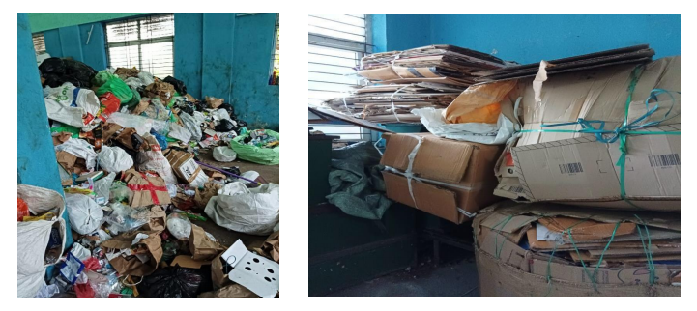

Seperation Of Waste

**Computer Science Engineering, ACS College Of Engineering Page | 30**

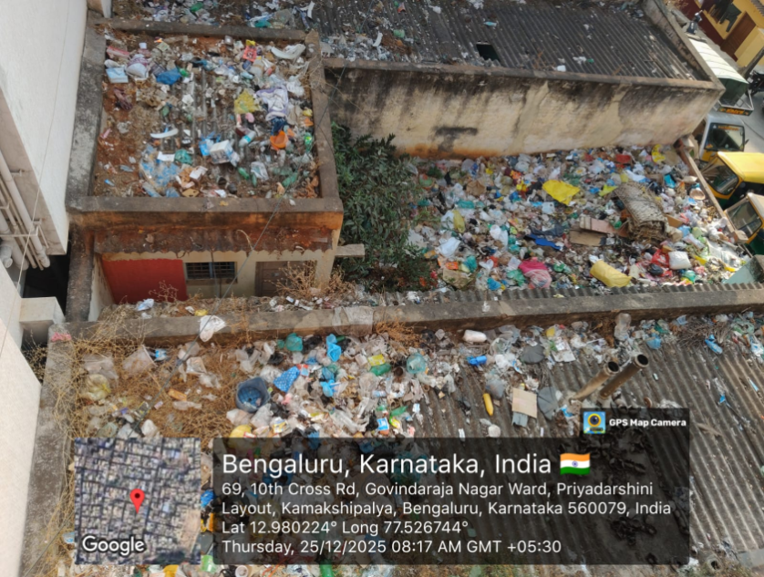

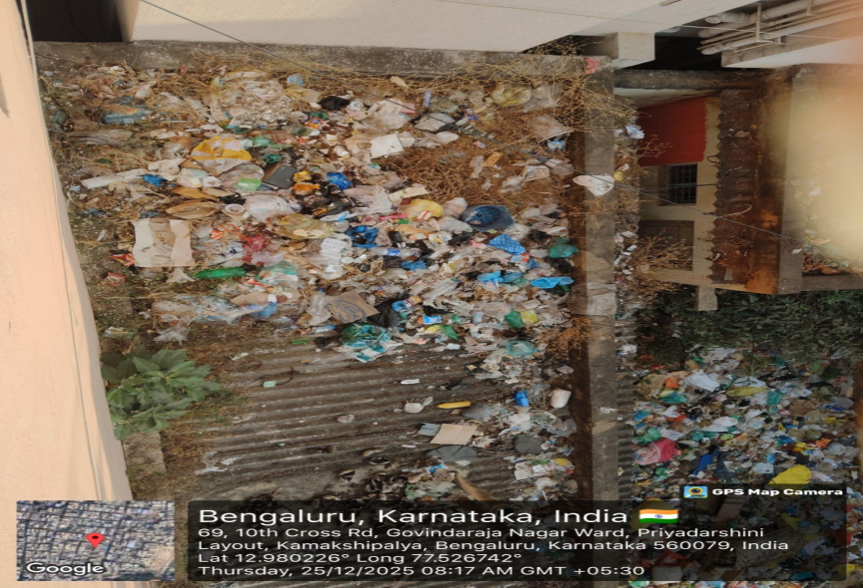

Collection Of Waste

**Computer Science Engineering, ACS College Of Engineering Page | 31**

**MODULE 4 - WATER CONSERVATION**

**Introduction:**

Water conservation involves using water efficiently and wisely to minimize waste and ensure sustainable water resources for present and future generations. It includes practices such as reducing water usage, fixing leaks, using water-saving technologies, capturing and storing rainwater, and implementing policies to promote water-efficient practices in agriculture, industry, and households.

## Water Conservation Spot was visited on 24th December 2025.I visited Sir M Visvesvaraya Rain Water Harvesting Theme Park located in Jayanagar Bangalore District about the distance 23.4 km from my college.

**Importance of Water Conservation**:

Water conservation is crucial for several reasons:

Conserving water helps ensure that there is enough water available for current and future needs, including drinking water, agriculture, industry, and ecosystem health.

Preserving water resources helps maintain the balance of aquatic ecosystems, supporting biodiversity, wildlife habitats, and aquatic life.

By reducing water usage and waste, water conservation measures can help mitigate the impacts of droughts and water scarcity, particularly in regions prone to water shortages.

Treating and transporting water requires energy. By conserving water, we also save energy, reducing greenhouse gas emissions and mitigating climate change.

Water conservation can lead to cost savings for individuals, businesses, and governments through reduced water bills, lower infrastructure costs, and increased efficiency in water use.

Climate change is expected to exacerbate water scarcity and variability in many regions. Water conservation measures can help communities become more resilient to the impacts of climate change by reducing vulnerability to water shortages and droughts.

Conserving water helps maintain the beauty and functionality of natural landscapes, including rivers, lakes, wetlands, and forests, which provide important ecological, recreational, and cultural values.

**Computer Science Engineering, ACS College Of Engineering Page | 32**

**Current Water Usage Trends:**

According to the United Nations, global water usage has been growing at twice the rate of population growth over the last century. This has led to an increase in water stress and scarcity in many parts of the world. In addition, water usage patterns are not sustainable, with agriculture being the biggest water user, followed by industry and domestic use.

**Strategies for Water Conservation:**

1. Fixing leaks: One of the simplest ways to conserve water is to fix leaks in pipes, faucets, and toilets. A leaky faucet can waste up to 20 gallons of water per day, while a leaking toilet can waste up to 200 gallons per day.
2. Using water-efficient appliances: Using water-efficient appliances such as low-flow showerheads, toilets, and washing machines can help to conserve water. These appliances use less water while still providing the same level of performance.
3. Harvesting rainwater: Harvesting rainwater is an excellent way to conserve water. Rainwater can be collected in a storage tank and used for various purposes such as watering plants, flushing toilets, and washing clothes.
4. Reusing water: Reusing water can also help to conserve water. Gray water from showers, sinks, and washing machines can be collected and used for irrigation or flushing toilets.
5. Educating the public: Educating the public about the importance of water conservation can also play a vital role in promoting water conservation. This can be done through campaigns, social media, and community outreach programs

**Rain water harvesting:**

Rainwater harvesting is the process of collecting, storing, and using rainwater for various purposes.

The primary objective of rainwater harvesting is to conserve water and minimize the use of groundwater sources, which are often over-exploited and depleting. Rainwater harvesting is an ancient practice that has been used for centuries in many parts of the world to collect and store rainwater for drinking, cooking, irrigation, and other household uses. Rainwater harvesting has many benefits, including reducing the demand for groundwater sources, preventing floods, improving water quality, and providing an alternative source of water during droughts. Rainwater is also free from contaminants that are commonly found in groundwater sources and is ideal for non-potable uses such as irrigation, toilet flushing, and cleaning.

To implement rainwater harvesting, it is essential to have proper infrastructure and maintenance systems in place. The collection and storage systems must be designed and constructed to handle the amount of rainfall in the area and to prevent contamination. Regular cleaning and maintenance of the storage tanks and other components of the system are necessary to prevent the growth of bacteria and other harmful organisms.

**Computer Science Engineering, ACS College Of Engineering Page | 33**

Rainwater harvesting can be implemented in a variety of settings, including residential, commercial, and industrial. Many countries and states have laws mandating the implementation of rainwater harvesting systems in new construction projects or as part of retrofitting existing buildings.

Rainwater harvesting is an effective way to conserve water and reduce the demand on groundwater sources. Proper infrastructure and maintenance are essential for successful implementation, and the benefits of rainwater harvesting extend beyond water conservation to include improved water quality and flood prevention.

**Proposal for Water Conservation in ACS College Of Engineering**:

Water conservation is a critical aspect of sustainable campus management. ACS College of

Engineering recognizes the importance of responsible water usage and is committed to implementing water conservation measures to minimize water wastage, promote efficient water management practices, and contribute to environmental sustainability. This proposal outlines a comprehensive plan for water conservation initiatives at our institution.

**Objectives:**

1. Reduce overall water consumption on campus.

2. Implement efficient water management practices to minimize wastage.

3. Raise awareness among students, faculty, and staff about the importance of water conservation.

4. Implement sustainable water infrastructure upgrades to improve efficiency.

5. Monitor and track water usage to measure progress and identify areas for improvement.

**Proposed Initiatives:**

1. Installation of Water-saving Fixtures: Replace existing fixtures with low-flow faucets, shower heads, and toilets to reduce water usage in restrooms and other facilities across the campus.

2. Rainwater Harvesting Systems: Implement rainwater harvesting systems to capture and store rainwater for irrigation, landscaping, and non-potable uses on campus.

3. Greywater Recycling: Install greywater recycling systems to treat and reuse waste water from sinks, showers, and laundry facilities for non-potable purposes such as toilet flushing and irrigation.

4. Water-efficient Landscaping: Adopt xeriscaping techniques and drought-tolerant plants for landscaping to reduce water demand for irrigation and maintenance.

**Computer Science Engineering, ACS College Of Engineering Page | 34**

5.Leak Detection and Repair: Conduct regular inspections to identify and repair leaks in plumbing systems, irrigation systems, and campus infrastructure to minimize water wastage.

6. Educational Campaigns: Launch awareness campaigns, workshops, and educational programs to inform students, faculty, and staff about the importance of water conservation and provide practical tips for reducing water usage in daily activities.

7.Water Metering and Monitoring: Install water meters and monitoring systems to track water usage in different campus buildings and facilities, identify areas of high consumption, and implement targeted conservation measures.

8.Infrastructure Upgrades: Invest in sustainable water infrastructure upgrades, such as waterefficient appliances, water reuse systems, and smart irrigation controllers, to improve overall water efficiency on campus.

**Implementation Plan:**

1. Form a Water Conservation Committee comprising representatives from different departments to oversee the implementation of water conservation initiatives.

2. Conduct a water audit to assess current water usage patterns, identify areas for improvement, and set conservation targets.

3. Develop a timeline and budget for implementing the proposed initiatives, prioritizing highimpact and cost-effective measures.

4. Collaborate with vendors, contractors, and water conservation experts to procure materials, equipment, and services needed for implementation.

5. Launch awareness campaigns and educational programs to engage the campus community and encourage participation in water conservation efforts.

6.Monitor water usage regularly, track progress towards conservation goals, and make adjustments as needed to optimize efficiency

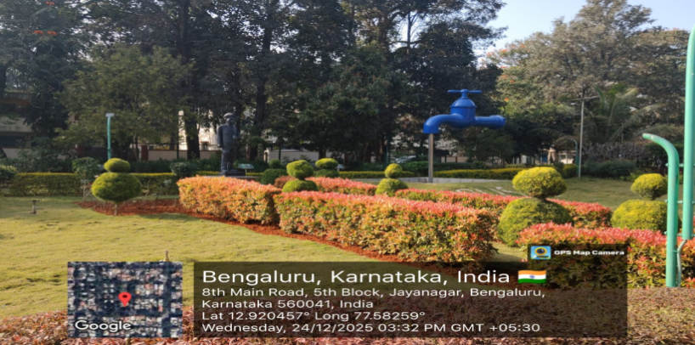

**Computer Science Engineering, ACS College Of Engineering Page | 35**

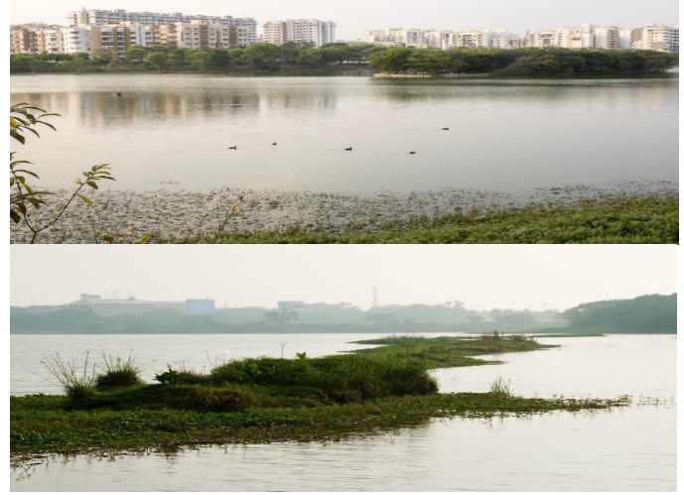

Rain Water Harvesting System, Sprinkler System

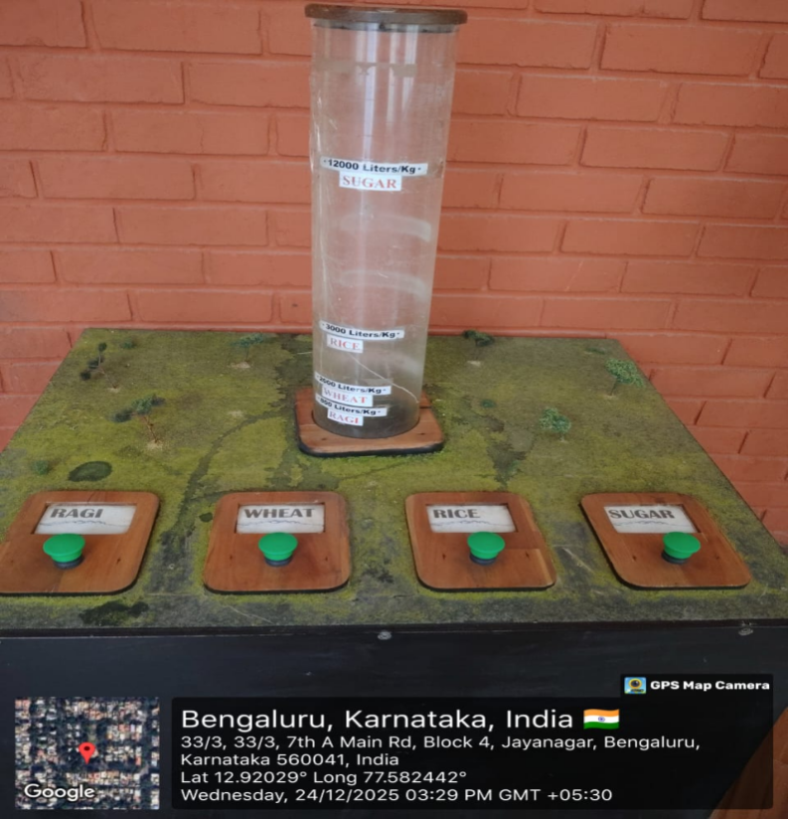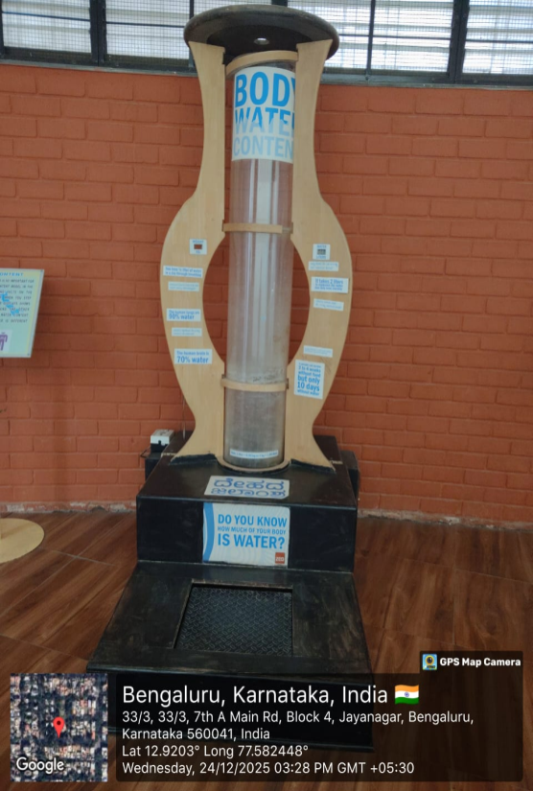

Food Water Content And Body Water Content

**Computer Science Engineering, ACS College Of Engineering Page | 36**

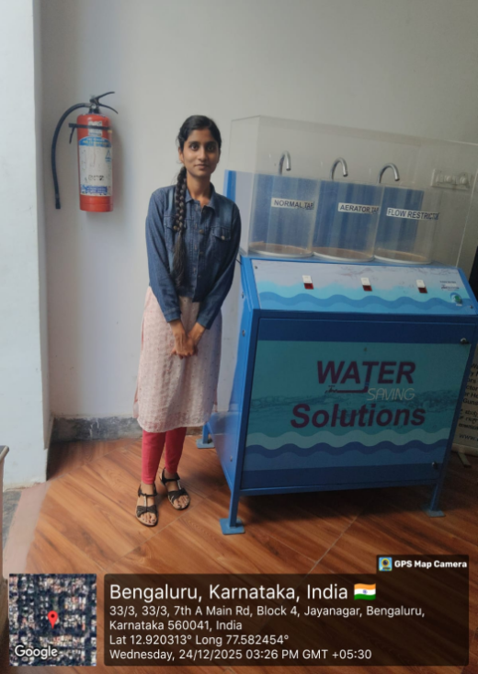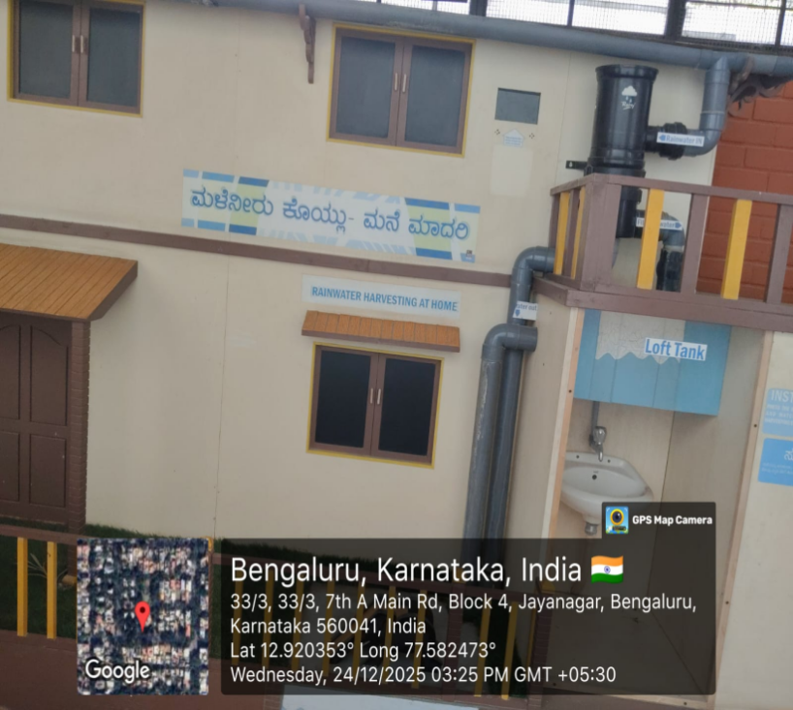

Rain Water Harvesting House Model

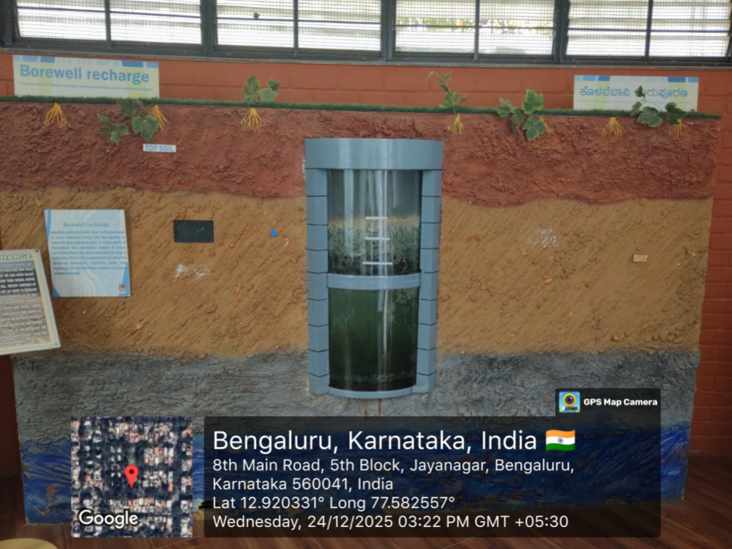

**Computer Science Engineering, ACS College Of Engineering Page | 37**

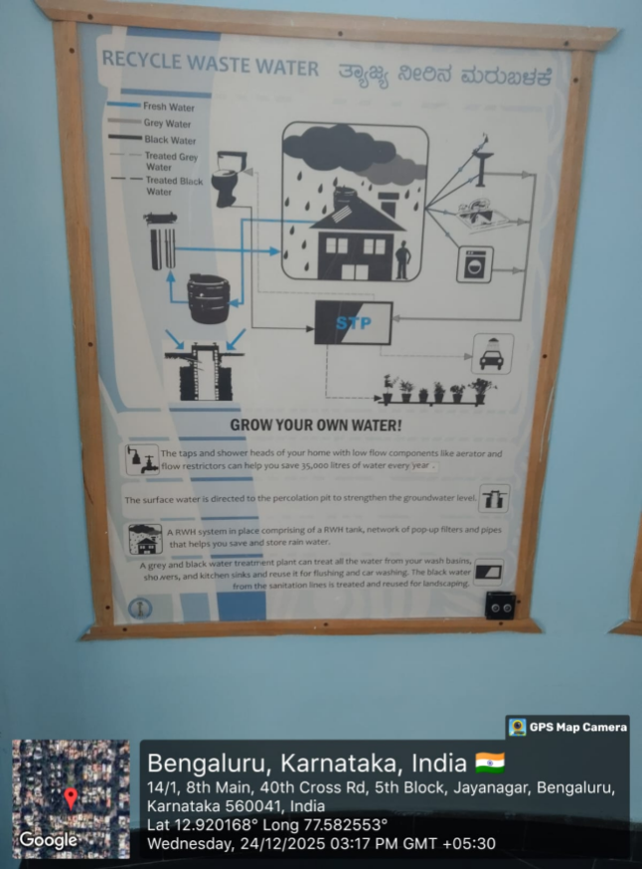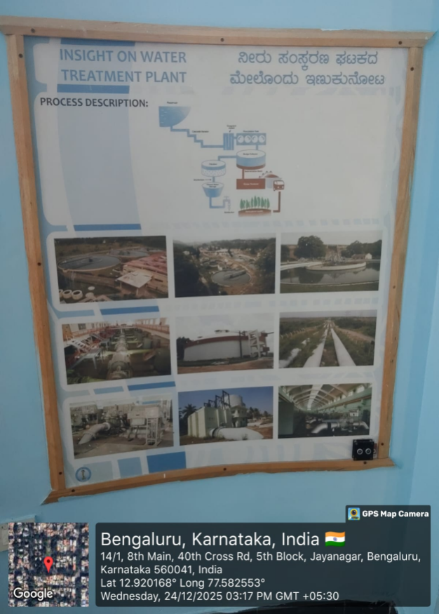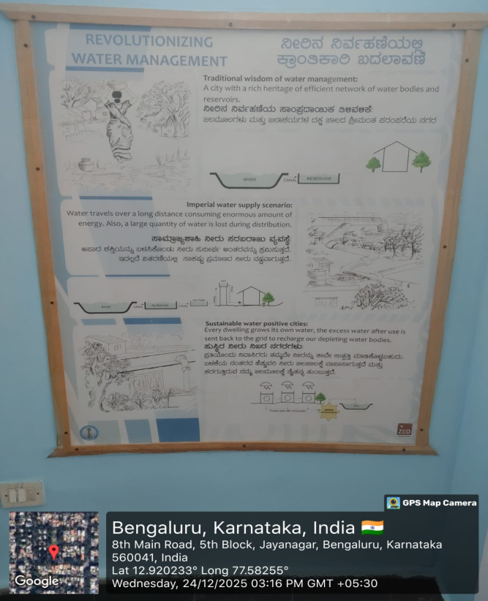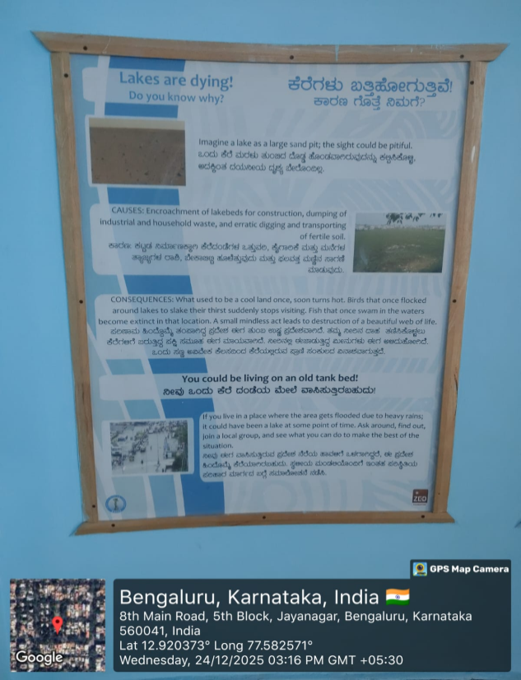

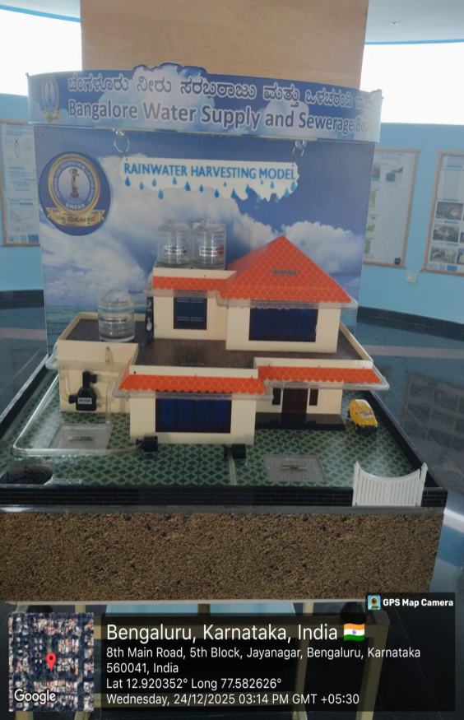

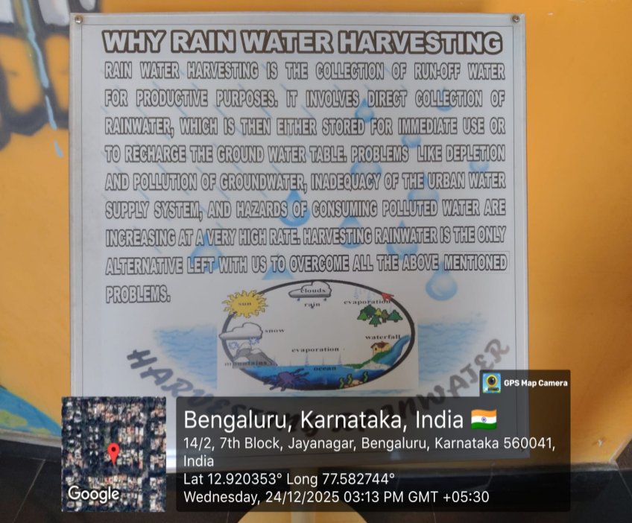

**Computer Science Engineering, ACS College Of Engineering Page | 38**

**Benefits Of Water Conservation**

* **Protects Ecosystems:** Keeps water in rivers, lakes, and wetlands, supporting wildlife and aquatic habitats.
* **Reduces Pollution:** Less water used means less wastewater, easing the load on treatment plants and preventing overflow into natural waters.
* **Combats Climate Change:** Saves energy used for pumping, heating, and treating water, cutting greenhouse gas emissions.
* **Preserves Resources:** Prevents aquifer depletion and maintains freshwater supply during dry periods.
* **Protects Ecosystems:** Keeps water in rivers, lakes, and wetlands, supporting wildlife and aquatic habitats.
* **Reduces Pollution:** Less water used means less wastewater, easing the load on treatment plants and preventing overflow into natural waters.
* **Combats Climate Change:** Saves energy used for pumping, heating, and treating water, cutting greenhouse gas emissions.
* **Preserves Resources:** Prevents aquifer depletion and maintains freshwater supply during dry periods.
* **Supports Recreation:** Keeps water available for recreational uses like pools, parks, and gardens.

**Computer Science Engineering, ACS College Of Engineering Page | 39**

**Conclusion:**

Water conservation is a shared responsibility that requires the collective efforts of the entire campus community. By implementing the proposed initiatives and fostering a culture of water conservation, ACS College of Engineering can reduce its environmental footprint, promote sustainability, and serve as a role model for other institutions. Together, we can make a significant impact in preserving this precious resource for future generations.

**Computer Science Engineering, ACS College Of Engineering Page | 40**

**MODULE 5 – FOOD WALK**

**Introduction:**

Food Walk is a unique experience that allows people to explore different cuisines and culinary cultures in a particular area. It is an opportunity for food enthusiasts to explore the local food scene, interact with local vendors, and taste a variety of dishes.

Food Walk was conducted on **24th December 2025**. I visited **Vijayanagar Food Street** which is located in **Bangalore Distric**t about the distance of 14.9km from our college **(ACS College of Engineering).**

**Purpose:**

The purpose of this report is to provide an overview of Food Walk, its significance, and how it contributes to the local economy.

**Methodology:**

The data for this report was collected through online research and interviews with food bloggers, tour operators, and local vendors.

**Overview:**

Food Walks are popular in many cities across the world. They are a fun way to discover the local food scene and learn about the culinary traditions of the area. A Food Walk usually lasts for a few hours, during which participants visit different food stalls, restaurants, and cafes to taste the local cuisine. The tour guide provides insights into the food, its history, and the culture behind it.

**Significance:**

Food Walks play a vital role in promoting tourism and boosting the local economy. They provide an opportunity for small food businesses to showcase their offerings and attract more customers.

Food Walks also help to preserve the local culinary traditions and promote sustainable food practice.

**Computer Science Engineering, ACS College Of Engineering Page | 41**

**Impact on the local economy:**

Food Walks have a significant impact on the local economy. They generate revenue for small food businesses, create employment opportunities, and attract tourists to the area.

By showcasing the local cuisine, Food Walks help to promote the area as a culinary destination, which in turn leads to increased tourism revenue.

**Challenges:**

One of the main challenges faced by Food Walks is the regulation of food safety and hygiene standards. Tour operators need to ensure that the food served during the walk is safe for consumption and meets the necessary hygiene standards. Another challenge is managing the crowds, especially during peak tourism seasons.

**Indigenous materials of the region used in cooking and their impact on**

**environment:**

Bangalore is located in the southern region of India and is known for its rich culinary traditions.

Many of the ingredients used in Bangalore's cuisine are sourced from the surrounding region, including both indigenous and non-indigenous materials. Here are some examples of indigenous materials used in cooking in Bangalore and their impact on the environment:

Coconuts: Coconuts are a widely used ingredient in Bangalore's cuisine, particularly in South Indian dishes. They are a sustainable crop and provide a range of benefits, such as providing coconut water and oil.

However, the excessive cultivation of coconut plantations can lead to environmental damage, including deforestation and soil degradation.

i. Spices: Bangalore is also known for its use of various spices, including turmeric, coriander, cumin, and black pepper. These spices are often grown locally and are an important source of income for farmers. However, their cultivation can require significant amounts of water and other resources, and can also lead to soil degradation and environmental pollution.

ii. Rice: Rice is a staple food in Bangalore's cuisine and is often grown in the surrounding region. While rice cultivation can provide important benefits for the environment, such as carbon sequestration and water conservation, it can also lead to soil degradation and water pollution if not managed sustainably.

iii. Curry Leaves: Curry leaves are an essential ingredient in South Indian cooking and are known for their medicinal properties. However, the over-harvesting of curry leaves can lead to soil degradation and the loss of biodiversity.

**Computer Science Engineering, ACS College Of Engineering Page | 42**

iv. Tamarind: Tamarind is a souring agent used in many South Indian dishes, and it is also an important cash crop in the region. However, the overuse of pesticides and fertilizers in tamarind cultivation can have a negative impact on soil quality and water resources.

v. Millets: Millets are a group of grains that are native to the region and are used in many traditional dishes. The cultivation of millets requires less water and fertilizers compared to other crops, making them a more sustainable option.

Overall, the use of indigenous materials in cooking in Bangalore can have both positive and negative impacts on the environment. While these materials provide important cultural and culinary benefits, it is important to ensure that they are sourced sustainably and that their cultivation does not lead to environmental degradation

**Food Walk Experience:**

On **24th December 2025**, a group of food enthusiasts embarked on a culinary journey through the vibrant streets of Bangalore, exploring the city's rich gastronomic heritage and sampling a diverse array of local delicacies. The food walk was organized, aimed to immerse participants in Bangalore's culinary culture, uncover hidden culinary gems, and celebrate the city's culinary diversity.

**Route and Stops:**

The food walk itinerary included stops at various iconic eateries, street food stalls, and traditional food markets across different neighborhoods of Bangalore. Participants were guided through bustling streets, aromatic alleys, and bustling markets, providing them with an authentic taste of Bangalore's culinary landscape.

1. Vijaynagar food street 147, 18th Cross Rd, Govindaraja Nagar Ward, Stage 2,

Vijayanagar, Bengaluru, Karnataka 560040

2. Vijayanagar is a street food gem that we recently discovered thanks to one devoted LBB Crew Member. Curious as ever, we boarded the Metro and got down at the Vijayanagar Metro Station. The street food scene in question is just a hop, skip, and jump from the station. Ask anyone for Vijayanagar Water Tank and they’ll guide you .

3. Start your binge eating at this cart (named Paddu Centre) which dishes out fluffy *paddus* (or *paniyarams*). Half a dozen costs INR 20, while a full plate INR

30. Served with white and red chutney(spicy), you can also get them packed, at an additional INR 5 per plate. They have *puliogare* rice and lemon rice as well. Next to Spurthy Gobi Centre for six kinds of Manchurian — *gobi*, potato,

**Computer Science Engineering, ACS College Of Engineering Page | 43**

4. Bonda, chilli *bajjis, vadas*, and raw banana *bajjis* are what you get at

Annapoorneshwari Bajji Centre in abundance. Priced at INR 5 a pop, order a mixed plate for INR 20. They also dish out *poori-sagu* priced at INR 30. South Indian (Bangarapette) chaat corner dishes up *sev puri, masala puri, bhel puri*, and *pani puri*, *dahi puri* but it’s the floating *pani pur*i that caught our fancy. And the white *pani*. Pani that’s as plain as water but packs quite a punch. The floating pani puri, is as the name sounds.

**Highlights:**

**Culinary Diversity**: Participants experienced the rich diversity of Bangalorean cuisine, from traditional South Indian fare to regional specialties and street food delights.

**Local Interactions**: Interactions with local vendors, chefs, and fellow food enthusiasts provided valuable insights into Bangalore's culinary traditions, food culture, and culinary heritage.

**Authentic Experiences**: The food walk offered authentic, off-the-beaten-path culinary experiences, allowing participants to discover hidden culinary gems and sample authentic local flavors.

**Community Engagement**: The food walk fostered a sense of community among participants, who bonded over their shared love for food and exploration, creating memorable experiences and lasting friendships.

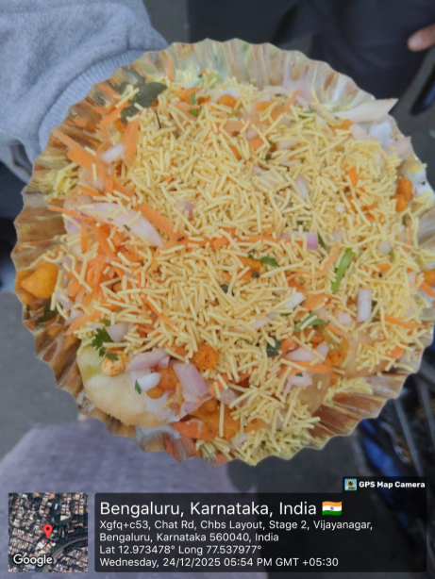

**Computer Science Engineering, ACS College Of Engineering Page | 44**

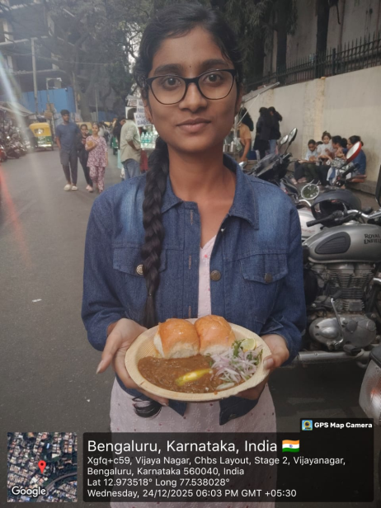



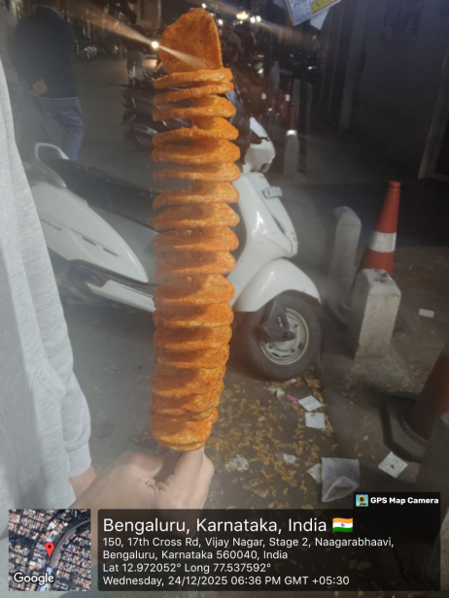

**Food Walk**

**Computer Science Engineering, ACS College Of Engineering Page | 45**

**Conclusion:**

The food walk in Bangalore was a resounding success, providing participants with a memorable culinary adventure and a deeper appreciation for Bangalore's vibrant food culture. Through immersive experiences, authentic flavors, and engaging interactions, the food walk celebrated the city's culinary diversity and showcased its rich gastronomic heritage. It served as a reminder of the power of food to connect people, bridge cultures, and create lasting memories.

**Computer Science Engineering, ACS College Of Engineering Page | 46**

**SUMMARY**

1*.* Plantation of a tree that will be adopted for years by me (Bhumika B.C). On a date of **13th December 2025**, we planted a Periwinkle plant in my home Bangalore and I am taking care for years.

2*.* Heritage walk and craft corner was planned on **12th December 2025**. I visited the

**Bangalore Fort** which is located in **Banglore District** about the distance of 48km from our college (**ACS College of Engineering**) and for craft corner visited which also located in **Kushala Kala Channapatna** about the distance of 52km from our college.

3.Has implemented a zero waste policy, where all waste generated on campus is either recycled or composted. The **ACS College of Engineering** has implemented a composting program that diverts food waste from the landfill and uses it to fertilize campus gardens and landscapes.

4.Water conservation is crucial for ensuring that we have enough water for all our needs, protecting the environment, and saving energy. By adopting various strategies such as fixing leaks, using water-efficient appliances, harvesting rainwater, reusing water, and educating the public, we can conserve water and ensure that it is available for future generations.

## 

## Water Conservation Spot was visited on 24th December 2025.I visited Sir M Visvesvaraya Rain Water Harvesting Theme Park located in Jayanagar Bangalore District about the distance 23.4 km from my college.

5.Food walks are a fun and educational way to explore new foods and cultures. They offer a unique experience that is not just about eating food but also about learning and exploring. Food walks can be enjoyed by people of all ages and backgrounds and are an excellent way to socialize and make new friends. If you are a food enthusiast looking for a new adventure, a food walk is definitely worth considering.

Food Walk was conducted on **24th December 2025**. I visited **Vijayanagar Food Street** which is located in **Bangalore Distric**t about the distance of 14.9km from our college **(ACS College of Engineering).**

**Computer Science Engineering, ACS College Of Engineering Page | 47**

**CONCLUSION**

Social connection and responsibility are essential for creating a better world for everyone. By working together and taking responsibility for our actions, we can advance social goals and improve the environment.

Social responsibility can be practiced passively or actively, and it must be intergenerational to have a lasting impact. Businesses that practice ethical decision making can avoid negative consequences and build stronger relationships with customers, employees, and the community. As individuals, we must make sustainable and ethical decisions, hold organizations accountable, and encourage sustainable practices.

Ultimately, social responsibility benefits everyone, and all individuals and organizations must contribute to the greater good of society and the environment.

**Computer Science Engineering, ACS College Of Engineering Page | 48**